The valve type Z2FRM is a 2-way flow control valve in sandwich plate design. It is used for keeping a flow constant, independent of pressure and temperature（与压力和温度无关）.

The valve basically comprises of a housing（壳体） (1) and one or two flow control cartridges （流量控制阀芯）.

The flow from channel A②/B② to channel A①/B① is controlled at the throttling point （节流点）(3). The throttle cross-section is set by turning the adjustment type (2) between the throttling point (3) and the throttling pin （节流销）(4). 通过旋进或旋出调节销子与套子之间的大小，控制流量。

In order to keep the flow in channel A①/B① constant, independent of the pressure, a pressure compensator（压力补偿器） (5) is fitted downstream（下游） of the throttling point (3).

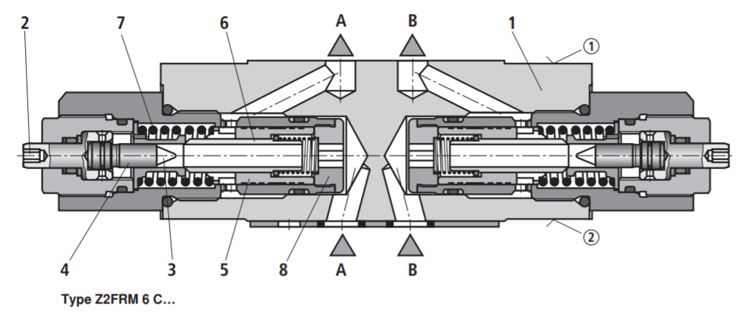

The compression spring (7) presses the pressure compensator (5) against the plug screw（旋塞） (8) and keeps the pressure compensator in the open position when there is no flow through the valve. When fluid flows through the valve, the pressure acting in channel A②/B② applies a force to the pressure compensator (5). The pressure compensator moves into the control position until the forces balance. If the pressure in channel A②/B② rises, the pressure compensator (5) moves in the closing direction until a balance of forces is once again attained. Due to this continuous compensation of the pressure compensator, a constant flow is obtained.

The free flow from channel A①/B① to channel A②/B② is via the check valve（止回阀） (6).

流量阀

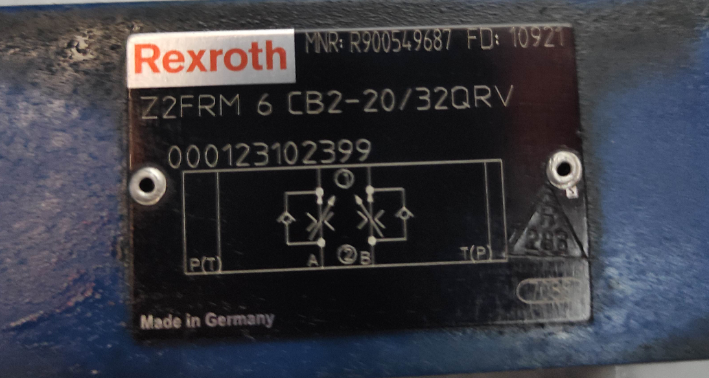

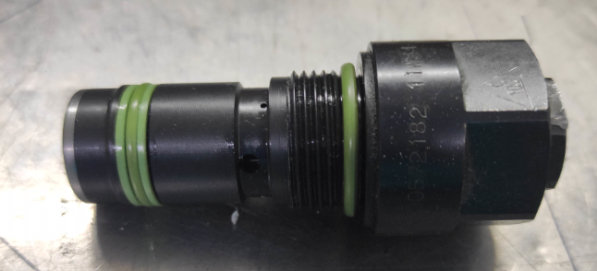

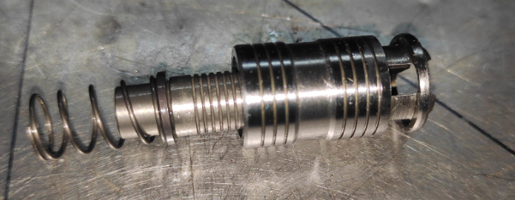

电磁阀 Directional spool valves, direct operated, with solenoid actuation 方向阀

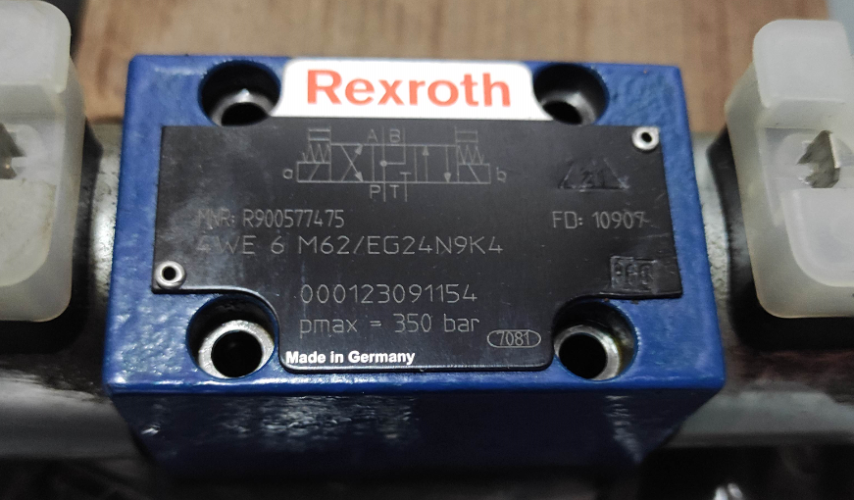

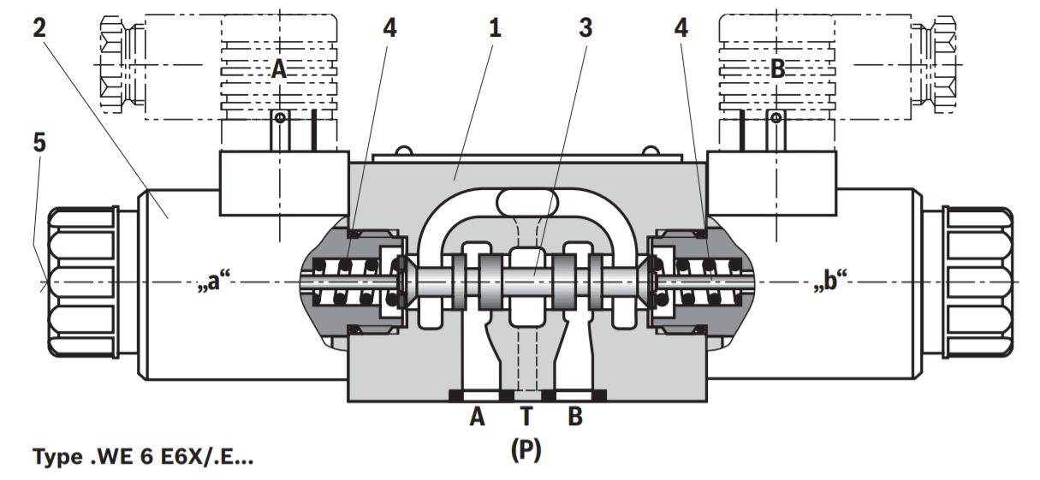

Parker

Pilot pressure 先导压力

Pilot先导式 operated check valves止回阀 from the Parker Manapak series CPOM are in sandwich design for easy configuration of stack systems堆叠系统. Depending on the function required, one or two pilot operated check valves are arranged in the ports A and/or B. The free flow direction is always from the valve side to the manifold side 歧管侧.

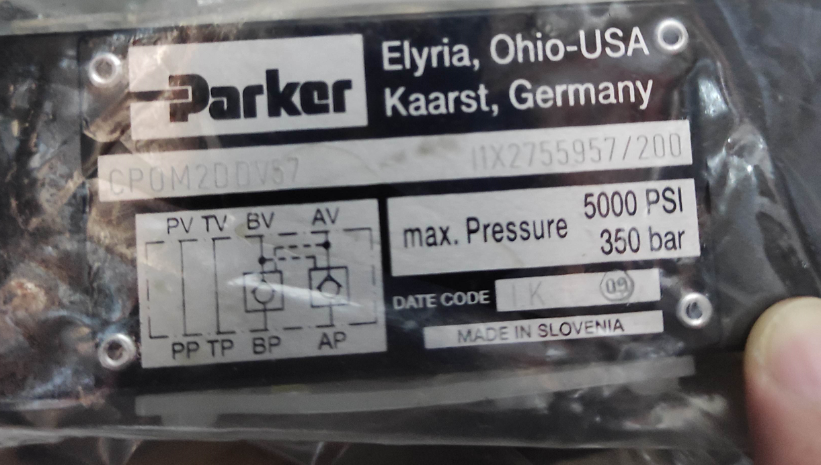

**Function**

The check valves open when flowing to the consumer side, where the opposing check valve is hydraulically-mechanically pilot operated simultaneously by a control spool, and thus the return flow is enabled from other consumer sides.

止回阀在流向消耗侧时会打开，在对侧的止回阀通过控制滑阀同时进行液压机械先导操作，因此可以从其他消耗侧实现回流。

valve poppet 阀座

